

## SW

Automation Summary Report

 SWAGLAB Web Application

# TABLE OF CONTENT

Contents

DECLARATION 1

ACKNOWLEDGEMENT 2

TABLE OF CONTENT 3

1. INTRODUCTION 1
   1. Test Environments 2
   2. Test Tools 2
2. OBJECTIVES 3
3. METHODOLOGY 4
   1. System overview 4
   2. Mind Maps 5
      1. Login Page 5
      2. Inventory Page 5
      3. Cart Page 6
      4. Checkout Page 6
      5. Checkout Overview Page 6
4. Test Cases 7
   1. Login Functionality 7
   2. Hamburger button Functionality 8
   3. Cart Functionality 9
   4. Checkout Functionality 10
   5. Checkout Overview Functionality 11

4.6 Inventory Functionality 12

1. ISSUES 13

6 REFERENCES 14

7APPENDICES 15

* 1. Source Code 15

7.1.1 login function 15

7.1.2 inventory function 16

7.1.3. cart function 17

7.1.4. checkout function 18

# INTRODUCTION

Software testing is a method of testing whether the actual software product is as expected requirements and ensuring that the software product is error-free. There are two types of tests: Manual testing and Automation testing. Manual software testing is the human quality assurance engineers test the quality of newly developed software without using anything automatic tools. Automated testing is the method of testing software products with specific tools and frameworks to minimize human intervention and maximize quality. Purpose both types of testing are to identify defects or defects and ensure that the product is defect-free. As software quality assurance engineers need to learn about test automation and manual testing. In this assignment, we can gain knowledge about test automation and manual testing. For that we use the " Swag Labs " open-source online business management web portal.

## Test Environments

|  |  |
| --- | --- |
| Resources | Description |
| Laptop | acer |
| Web Browser | chrome |
| Operation System | Windows 11 |
| Internet | SLT Fiber |

*Table 1. 1 Test Environment*

## Test Tools

|  |  |
| --- | --- |
| Artifact | Tool |
| Test case design | Mind maps |
| Test Automation | Java, TestNG, Selenium |
| Diagram drawing | Draw.io |
| Integrated development environment | IntelliJ IDE for Enterprise Java and Web Developers  - 2024-12 |

*Table 1. 2 Test Tool*

# OBJECTIVES

In this assignment we basically focused about how to develop java basis automation testing code to test a website.

* Analysis the website for identify the testable objects and conditions
* Design the testcases and identify the suitable test techniques for testing
* Convert testcases into test scripts and prioritize them and identify test data for test the scripts
* Run the test scripts and log the test execution performs
* Generate the test completion report

# METHODOLOGY

## System overview

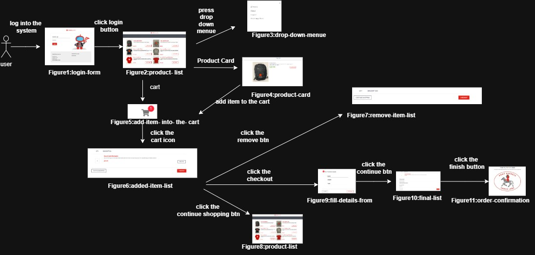

<https://drive.google.com/drive/folders/1bLH6gYiy3eGjxs5EBybzjFTYuKN8CaIw?usp=sharing> (Please visit Google drive link for clear view images)

## Mind Maps

### Login Page

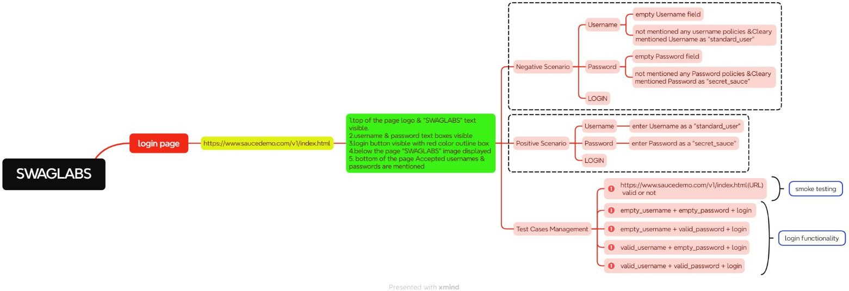

<https://drive.google.com/drive/folders/1bLH6gYiy3eGjxs5EBybzjFTYuKN8CaIw?usp=sharing> (Please visit Google drive link for clear view images)

### Inventory Page

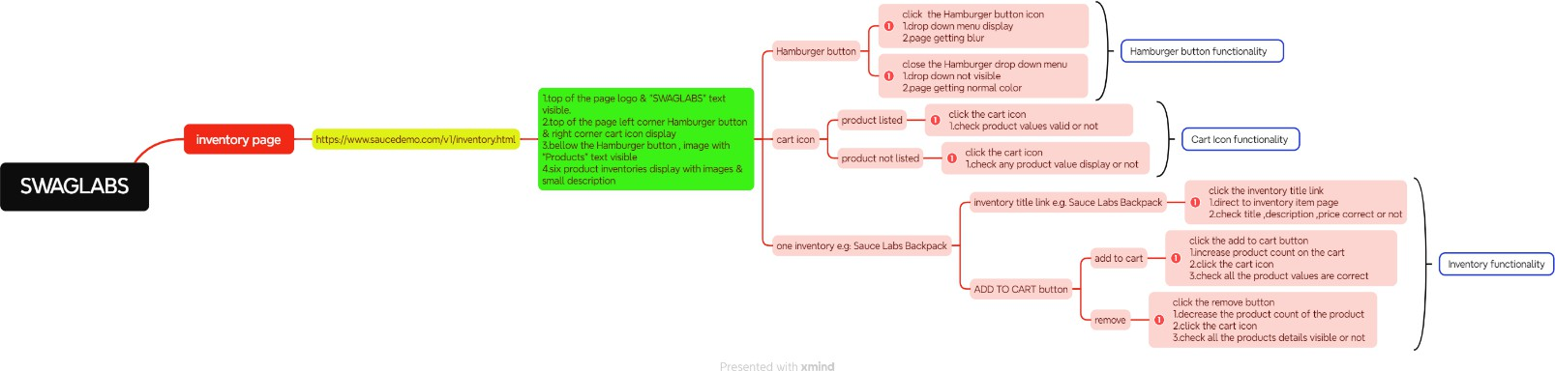

<https://drive.google.com/drive/folders/1bLH6gYiy3eGjxs5EBybzjFTYuKN8CaIw?usp=sharing> (Please visit Google drive link for clear view images)

### Cart Page

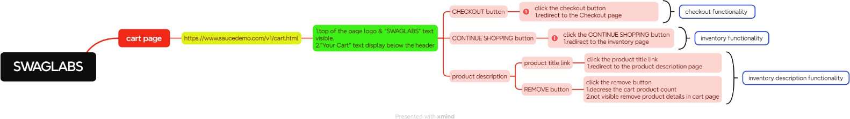

<https://drive.google.com/drive/folders/1bLH6gYiy3eGjxs5EBybzjFTYuKN8CaIw?usp=sharing> (Please visit Google drive link for clear view images)

### Checkout Page

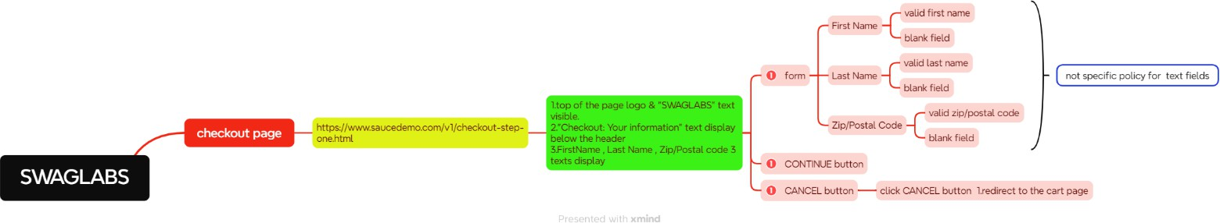

<https://drive.google.com/drive/folders/1bLH6gYiy3eGjxs5EBybzjFTYuKN8CaIw?usp=sharing> (Please visit Google drive link for clear view images)

### Checkout Overview Page

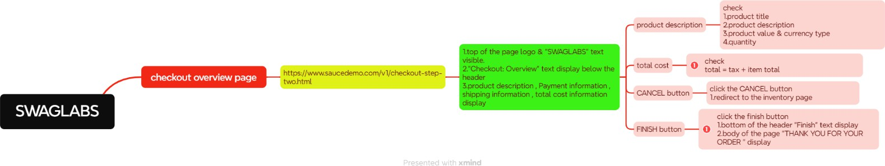

<https://drive.google.com/drive/folders/1bLH6gYiy3eGjxs5EBybzjFTYuKN8CaIw?usp=sharing> (Please visit Google drive link for clear view images)

# Test Cases

## Login Functionality

|  |  |
| --- | --- |
| **Test Scenario: Login Functionality [TS_001]** | |
| **Testcase No** | **Testcase Title** |
| TC_LF_001 | Validate the given URL is valid URL (smoke testing) |
| TC_LF_002 | Validate the Login function by providing empty username & empty password |
| TC_LF_003 | Validate the Login function by providing empty username & valid password |
| TC_LF_004 | Validate the Login function by providing valid username & valid password |

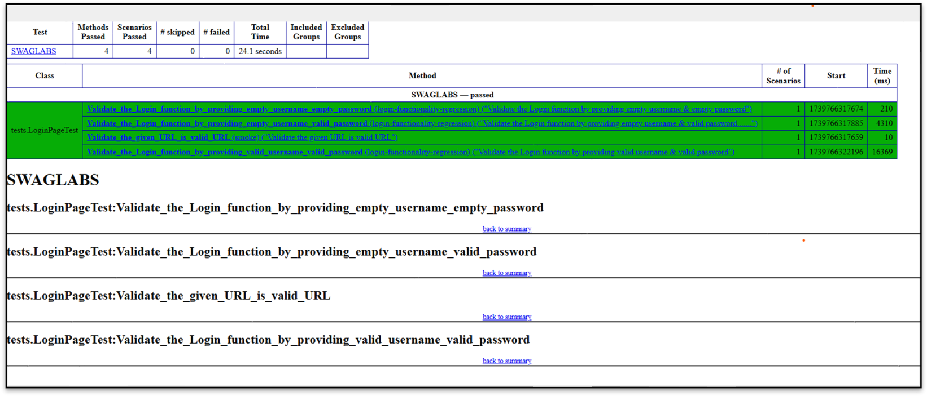<https://drive.google.com/drive/folders/1bLH6gYiy3eGjxs5EBybzjFTYuKN8CaIw?usp=sharing> (Please visit Google drive link for view full testcases in excel sheet)

**Figure1-[login-functionality-testcases]**

## Hamburger button Functionality

|  |  |
| --- | --- |
| **Test Scenario: Login Functionality [TS_002]** | |
| **Testcase No** | **Testcase Title** |
| TC_HBF_001 | Validate Hamburger button Functionality |
| TC_HBF_002 | Validate Dropdown Menu Close Button Functionality |

<https://drive.google.com/drive/folders/1bLH6gYiy3eGjxs5EBybzjFTYuKN8CaIw?usp=sharing> (Please visit Google drive link for view full testcases in excel sheet)

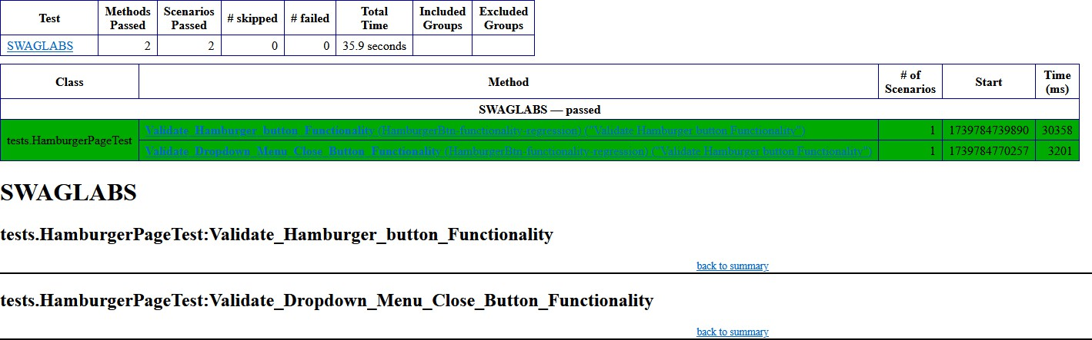

**Figure2-[HamburgerBtn-functionality-testcases]**

## Cart Functionality

|  |  |
| --- | --- |
| **Test Scenario: Cart Functionality [TS_003]** | |
| **Testcase No** | **Testcase Title** |
| TC_CF_001 | Validate "Add to Cart" Button Functionality |
| TC_CF_002 | Validate "Remove" Button Functionality |
| TC_CF_003 | Validate "Continue Shopping" Button Functionality |

<https://drive.google.com/drive/folders/1bLH6gYiy3eGjxs5EBybzjFTYuKN8CaIw?usp=sharing> (Please visit Google drive link for view full testcases in excel sheet)

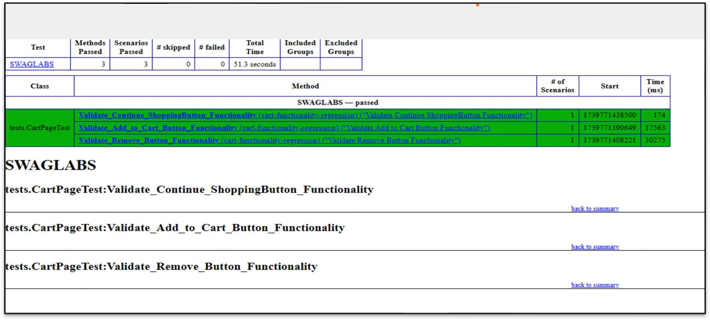

**Figure3-[cart-functionality-testcases]**

## Checkout Functionality

|  |  |
| --- | --- |
| **Test Scenario: Cart Functionality [TS_004]** | |
| **Testcase No** | **Testcase Title** |
| TC_COF_001 | Validate "Checkout" Button Functionality |
| TC_COF_002 | Validate "Continue" Button with Empty Field in form |
| TC_COF_003 | Validate "Cancel" Button Functionality |

<https://drive.google.com/drive/folders/1bLH6gYiy3eGjxs5EBybzjFTYuKN8CaIw?usp=sharing> (Please visit Google drive link for view full testcases in excel sheet)

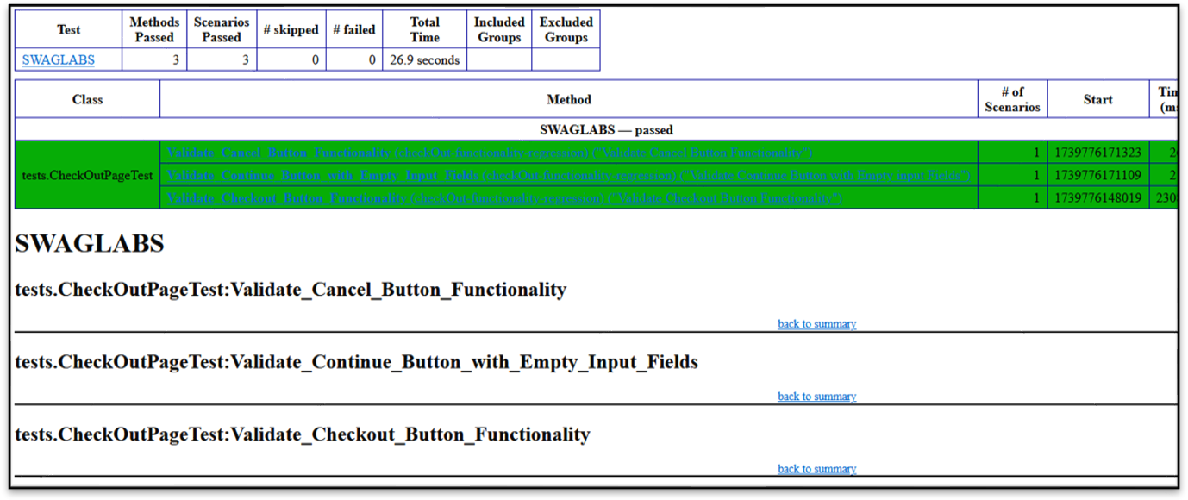

**Figure4-[checkOut-functionality-testcases]**

## Checkout Overview Functionality

|  |  |
| --- | --- |
| **Test Scenario: Checkout Overview Functionality [TS_005]** | |
| **Testcase No** | **Testcase Title** |
| TC_COVF_001 | Validate Successful Processing of Total Product Calculation |
| TC_COVF_002 | Validate Successful Functionality of the FINISH Button |

<https://drive.google.com/drive/folders/1bLH6gYiy3eGjxs5EBybzjFTYuKN8CaIw?usp=sharing> (Please visit Google drive link for view full testcases in excel sheet)

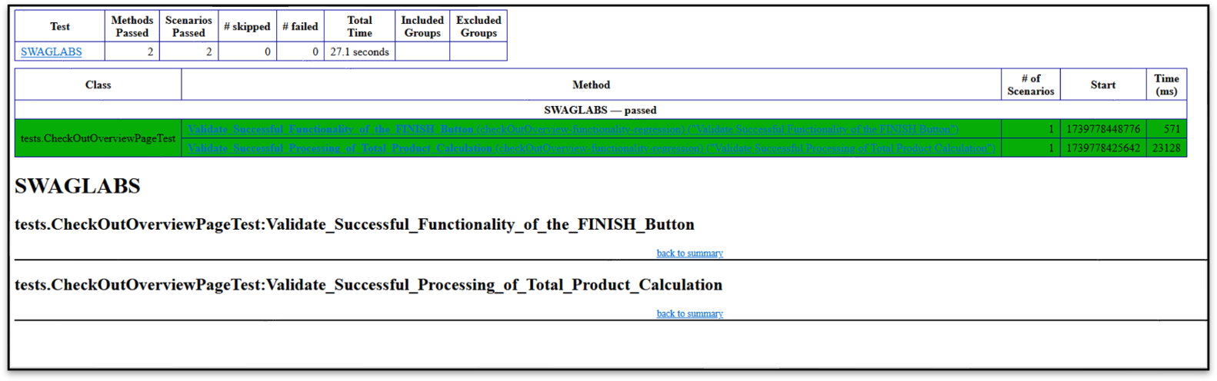

**Figure6-[checkOutOverview-functionality-testcases]**

## Inventory Functionality

|  |  |
| --- | --- |
| **Test Scenario: Checkout Overview Functionality [TS_006]** | |
| **Testcase No** | **Testcase Title** |
| TC_IF_001 | Validate That All Selected Product Details Are Displayed Correctly on the Inventory Item Page |

<https://drive.google.com/drive/folders/1bLH6gYiy3eGjxs5EBybzjFTYuKN8CaIw?usp=sharing> (Please visit Google drive link for view full testcases in excel sheet)

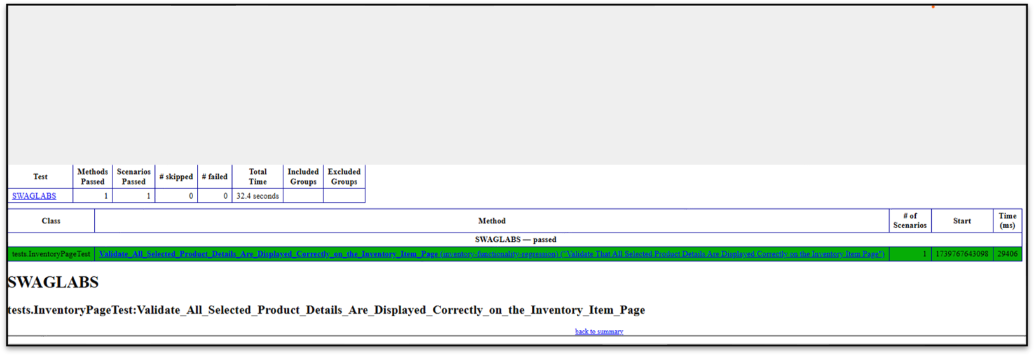

Figure6-[checkOutOverview-functionality-testcases]

# ISSUES

|  |  |
| --- | --- |
| Issues | Mitigation |
| Time management | Worked according to the planned schedule. |
| Requirement identification | Refer assessment few times and refer lecture recordings. |
| Lack of knowledge with automation script coding | Refer lecture materials, tutorial points, and YouTube videos. |

*Table 5. 1 Issues*

# 7APPENDICES

## Source Code

## login function

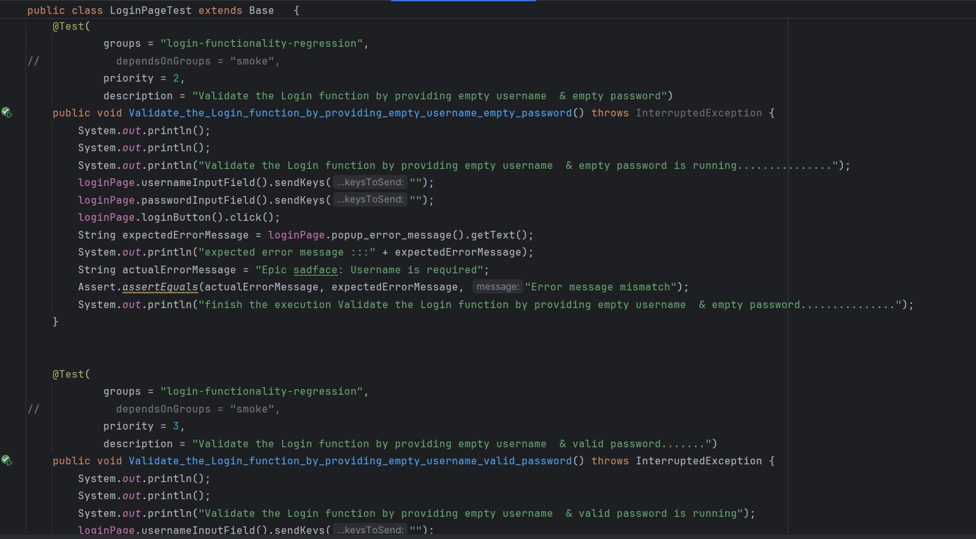

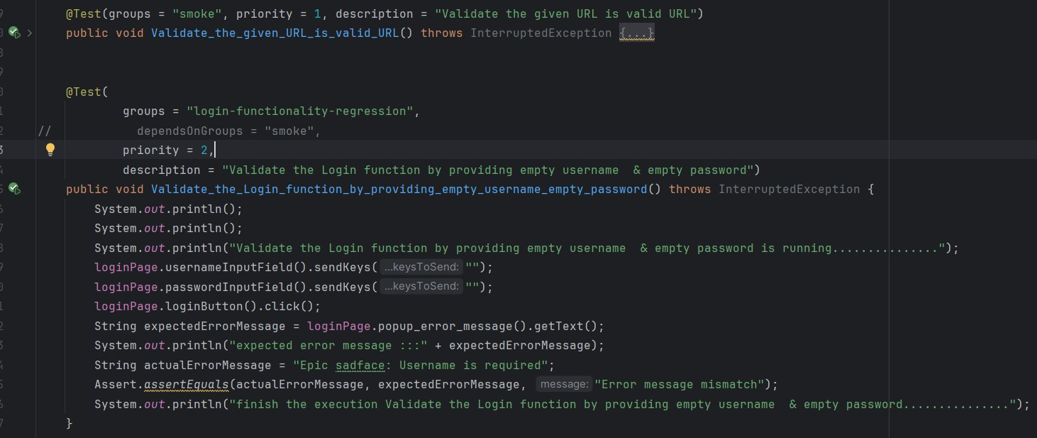

## inventory function

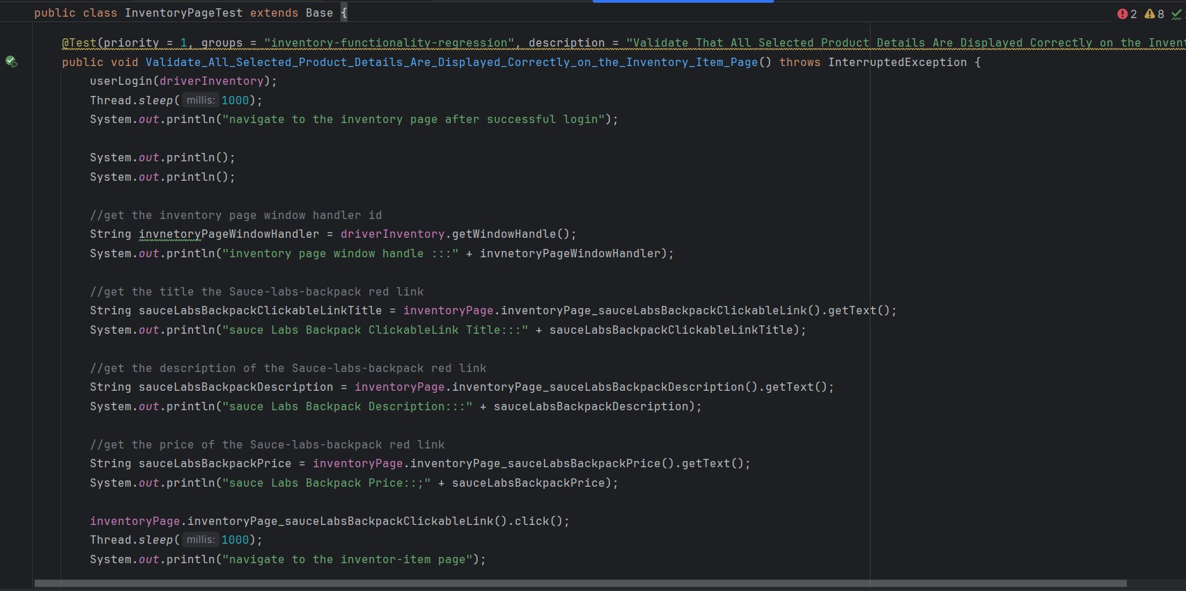

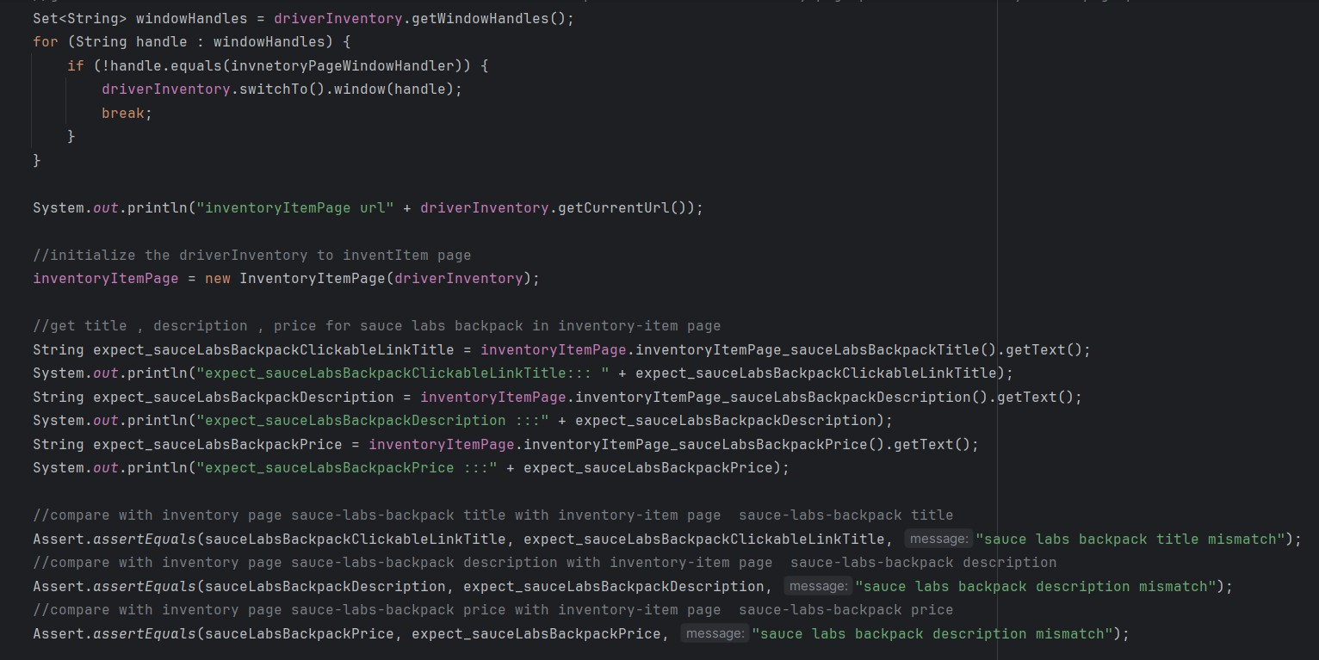

## cart function

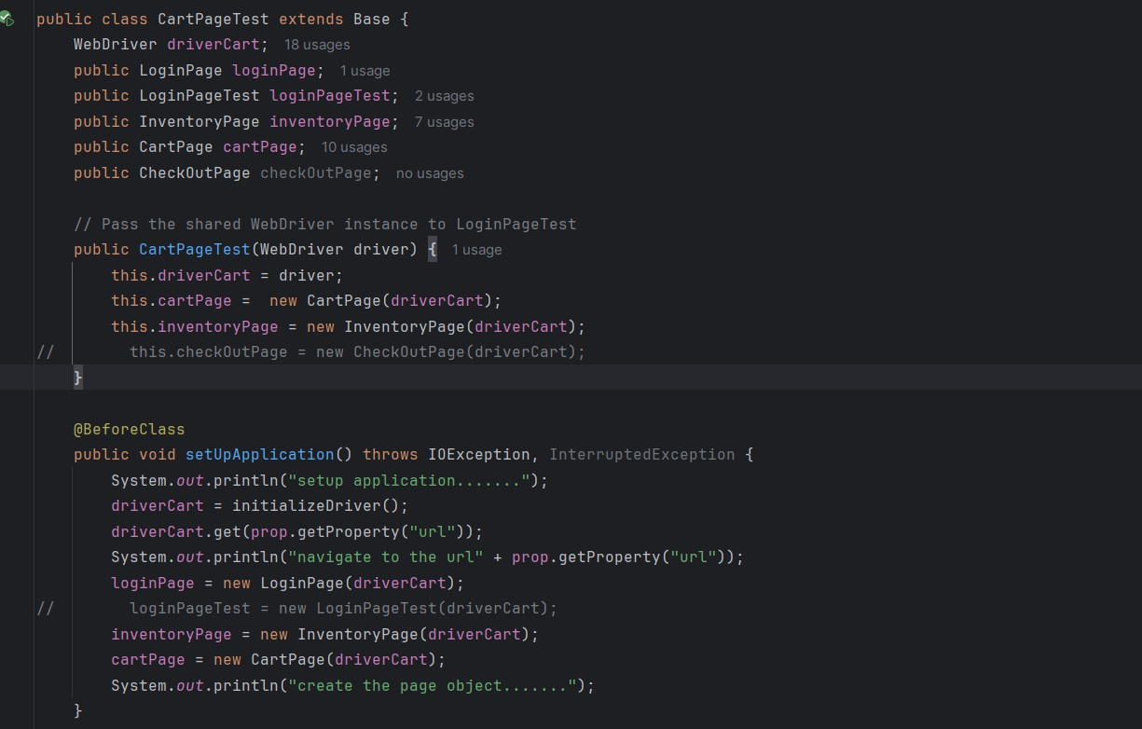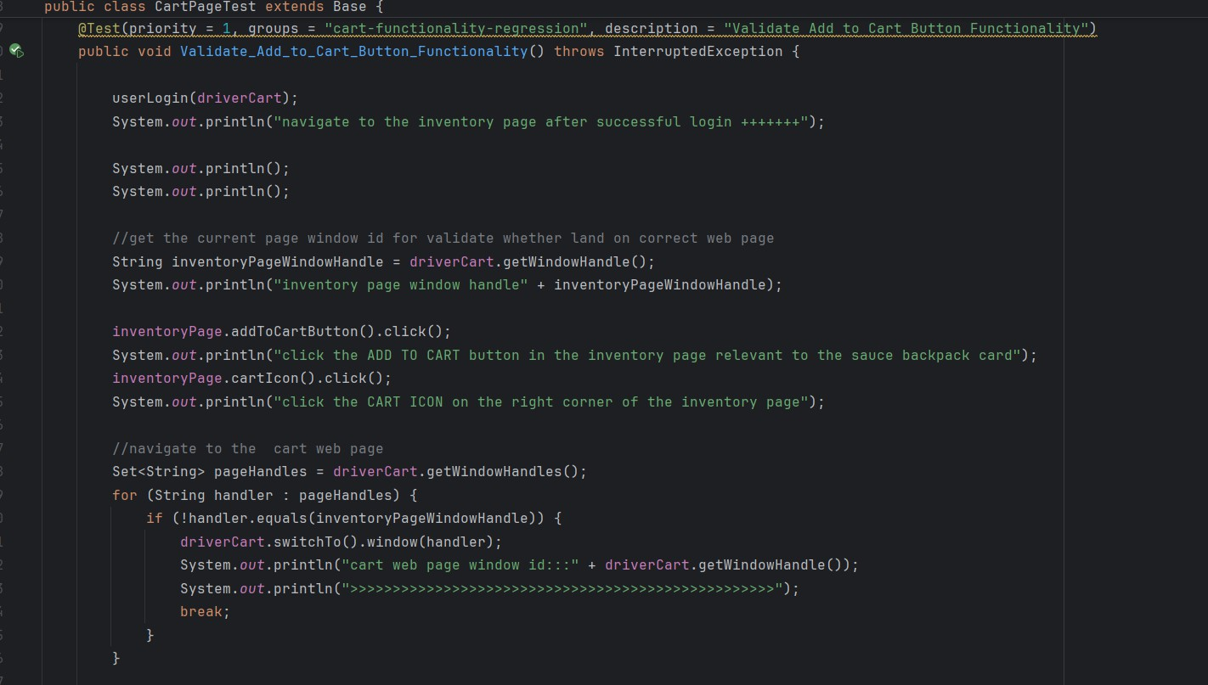

## checkout function

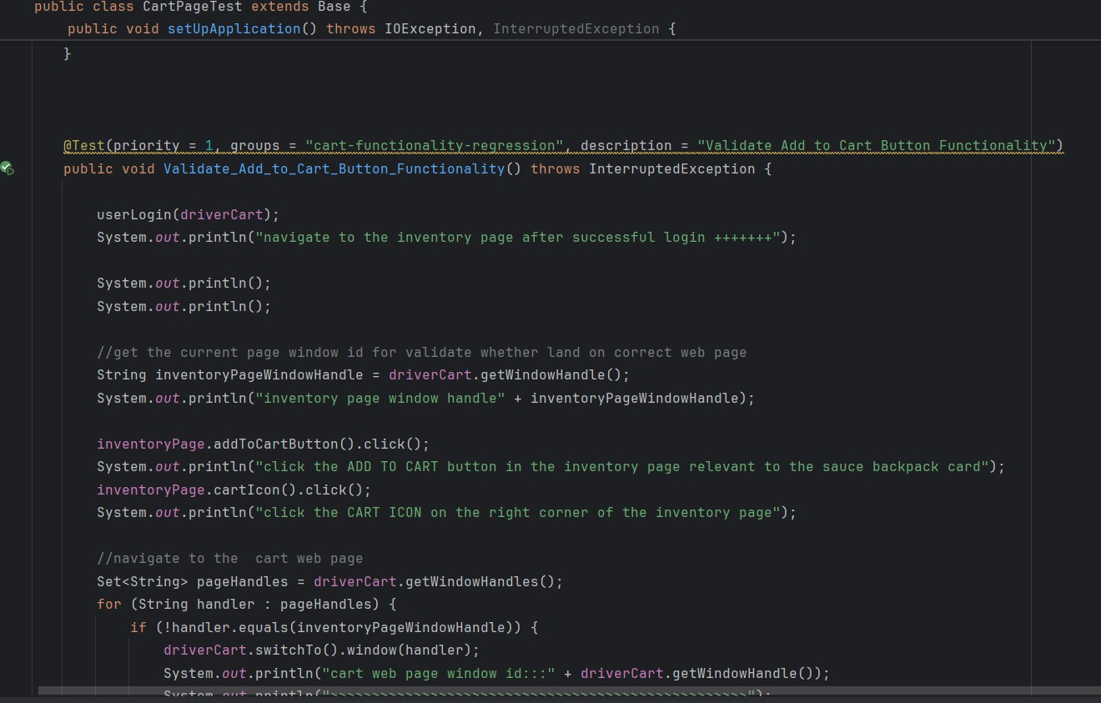

* + 1. **Hamburger button function**



 